Aim: Analysis of LTI System Responses to Standard Inputs Using Python
IDE:
Analyzing Discrete-Time Systems Using Z-Transform
The Z-transform is used for analyzing discrete-time signals and systems. The Z-transform of a discrete-time signal $x[n]$ is given by:
$$X\left(z\right)=\sum_{n=-∞}^{∞}{x[n]z^{-n}}$$
where $z$ is a complex variable, $X\left(z\right)$ represents the Z-transform of the signal.
Z-Transform Function
For an LTI system, the Z-transform function $H(z)$ is defined as:
$$H\left(z\right)=\frac{B(z)}{A(z)}=\frac{b_{0}+b_{1}z^{-1}+⋯+b_{m}z^{-m}}{a_{0}+a_{1}z^{-1}+⋯+a_{n}z^{-n}}$$
where $B(z)$ is the numerator polynomial, $A(z)$ is the denominator polynomial.
Stability
A discrete-time system is stable if all poles of its Z-transfer function lie inside the unit circle in the Z-plane. To check stability:
Calculate the poles of $H(z)$
Check if the magnitude of each pole is less than 1.
Causality
A system is causal if its impulse response $h[n]$ is zero $n<0.$ This generally means that the numerator polynomial should not have terms that depend on future values.
Time Invariance
A system is time-invariant if a time shift in the input results in an equivalent time shift in the output. For LTI systems, if the system is defined properly, it is generally assumed to be time-invariant.
Example
$$H\left(z\right)=\frac{\left(z^{2}+0.5\right)}{\left(z^{2}-1.5z+0.5\right)}$$
Bode Plot Analysis
Stability:
- Check the gain and phase margins.
- Ensure that both margins are positive for stability.
Causality:
- Examine the magnitude and phase at low frequencies.
- Confirm that the system behaves as a causal system (magnitude starts lower, phase starts near 0 and decreases).
Time Invariance:
- If the system is LTI, it is inherently time-invariant.
- Analyse the impulse response (if available) to verify consistent responses to delayed inputs.

Python Implementation
import numpy as np
import matplotlib.pyplot as plt
from scipy.signal import TransferFunction, lti

def analyze_z_transfer_function(num, den):
# Create a Transfer Function object
system = TransferFunction(num, den)

# Get the poles and zeros
zeros = system.zeros
poles = system.poles
print("Zeros:", zeros)
print("Poles:", poles)
# Stability Analysis
stable = all(np.abs(pole) < 1 for pole in poles)
print("Stability:", "Stable" if stable else "Unstable") 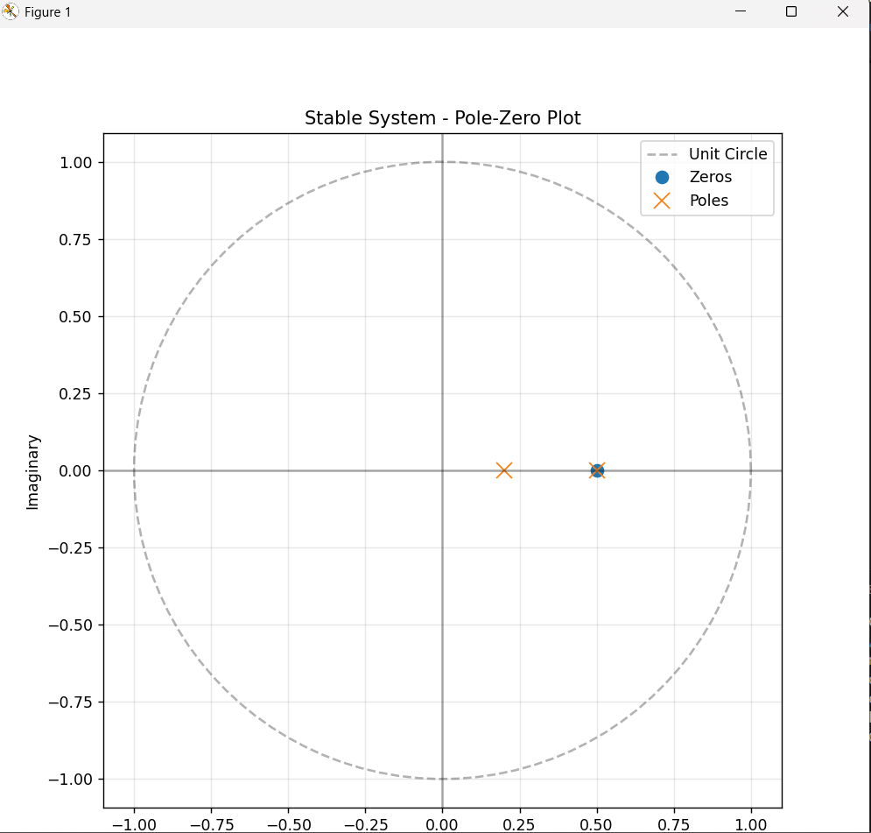

# Causality Analysis
causal = all(num[i] == 0 for i in range(len(num) - 1) if num[i + 1] == 0)
print("Causality:", "Causal" if causal else "Non-Causal")
# Time Invariance Analysis
time_invariant = True # For Z-transforms, generally time-invariant if system defined properly
print("Time Invariance:", "Time Invariant" if time_invariant else "Time Variant")
# Bode plot (magnitude and phase)
w, mag, phase = bode(system)
# Plot Bode plot
plt.figure(figsize=(12, 8))
plt.subplot(2, 1, 1)
plt.semilogx(w, mag) # Bode magnitude plot
plt.title('Bode Magnitude Plot')
plt.xlabel('Frequency [rad/s]')
plt.ylabel('Magnitude [dB]')
plt.grid()
plt.subplot(2, 1, 2)
plt.semilogx(w, phase) # Bode phase plot
plt.title('Bode Phase Plot')
plt.xlabel('Frequency [rad/s]')
plt.ylabel('Phase [degrees]')
plt.grid()
plt.tight_layout()
plt.show()
# Example: Analyzing a specific system H(z) = (z^2 + 0.5)/(z^2 - 1.5z + 0.5)
num = [1, 0.5] # Numerator coefficients
den = [1, -1.5, 0.5] # Denominator coefficients
analyze_z_transfer_function(num, den)
Transfer Function:
$$H\left(z\right)=\frac{0.5}{1-0.8z^{-1}}$$
Causality: This system is causal because the denominator has a non-negative exponent (i.e., all powers of $z^{-1}$ are non-negative).
Stability: The system is stable if the poles (the roots of the denominator) lie inside the unit circle. Here, the pole is $z=0.8,$ which is inside the unit circle, so the system is stable.
Time Invariance: The system is time-invariant because the coefficients do not depend on time.
Transfer function:
$$H\left(z\right)=\frac{1-z^{-1}}{1-0.5z^{-1}}$$
Causality: This system is causal.
Stability: The pole at $z=0.5$ is inside the unit circle, making the system stable.
Time Invariance: The system is time-invariant

Post Lab Exercise:
- Write a Python function to compute the Z-transform of an unit step function. verify whether the system is stable or unstable.
- Implement this for the system $H\left(z\right)=\frac{0.5\left(z-0.7\right)\left(z-0.9\right)}{\left(z-0.6\right)\left(z-0.4\right)}$ and verify whether the system is stable or unstable.

